Quarterly Meeting Information: Board Officer Elections to be held Dec. 8, 2025!

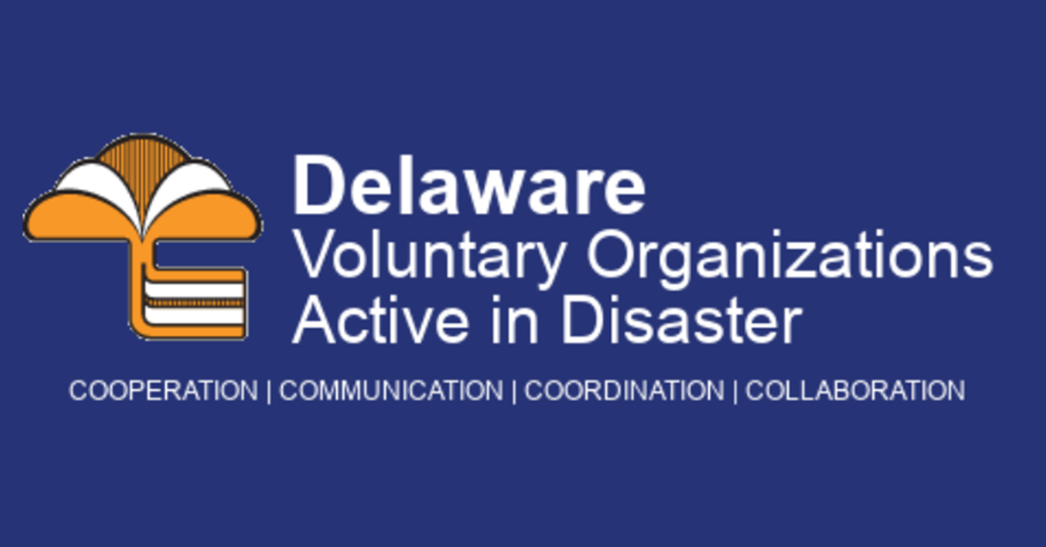

Please join us for our next quarterly meeting for Delaware VOAD:

When: Monday, December 8, 2025, from 2-3 pm
Where: DEMA Headquarters
165 Brick Store Landing Road Smyrna, DE 19977
Please go to the rear entrance and use the call button for entry

DEMA will host a facility tour following the meeting for anyone interested.

OR

Online Via Zoom
Join Zoom Meeting
https://udel.zoom.us/j/95444770438
One tap mobile
+13092053325,,95444770438# US
+13126266799,,95444770438# US (Chicago)

Please fill out this RSVP form to confirm your in-person attendance, so we can provide snacks and drinks: https://forms.gle/w3TLNZPEr24J4Bxm9

Our agenda

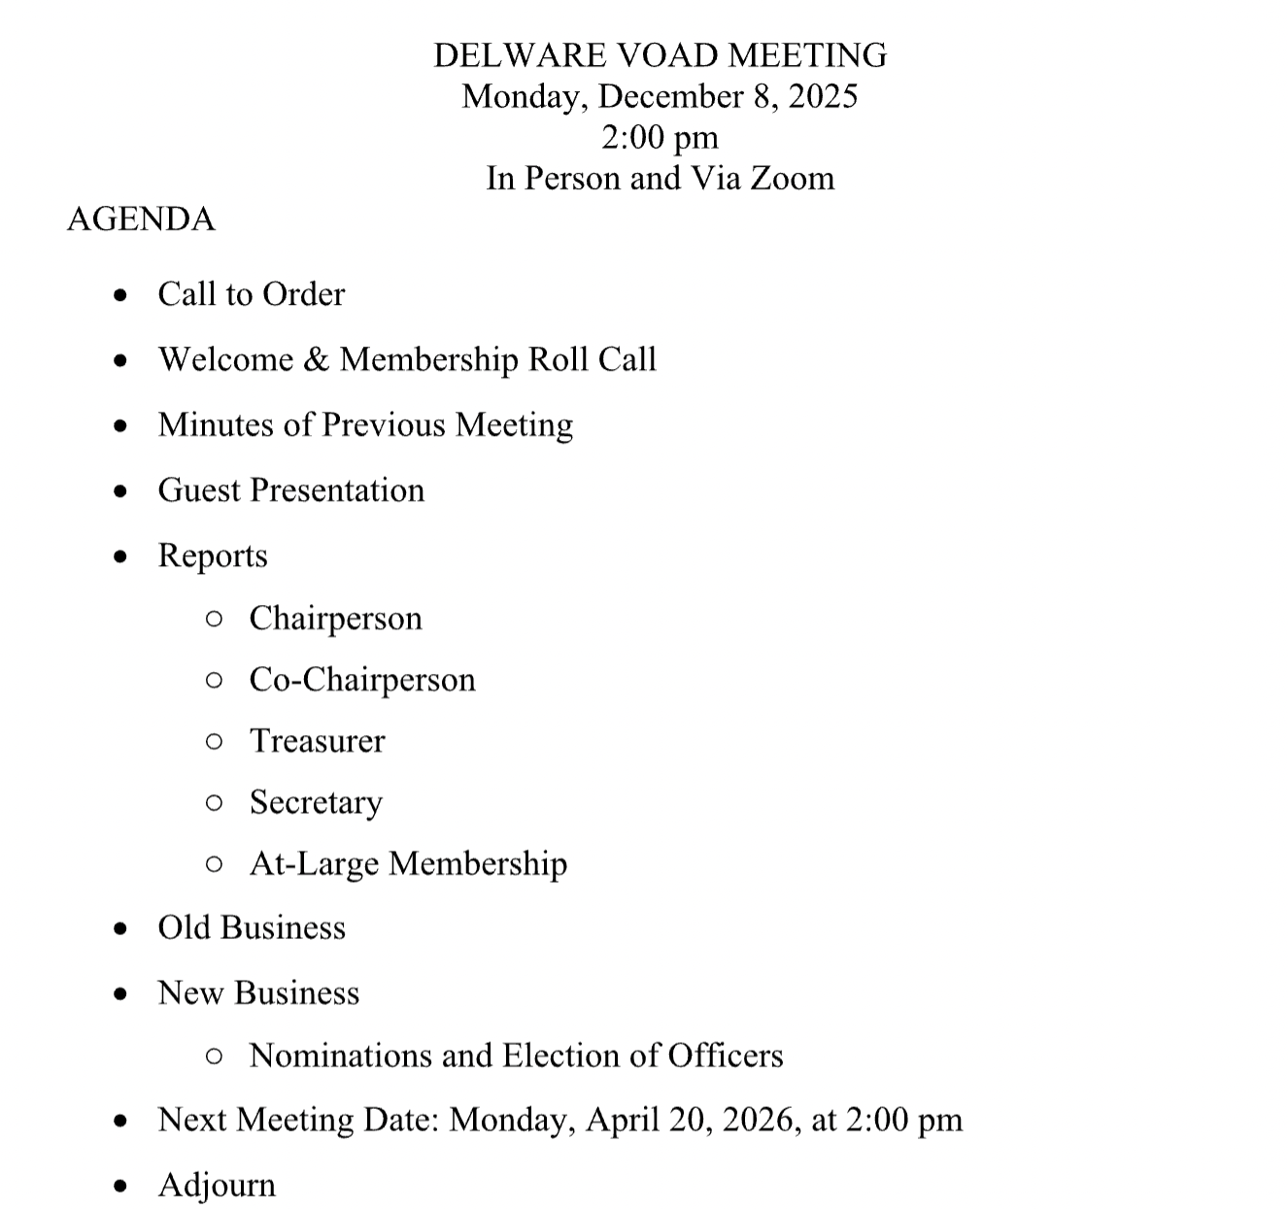

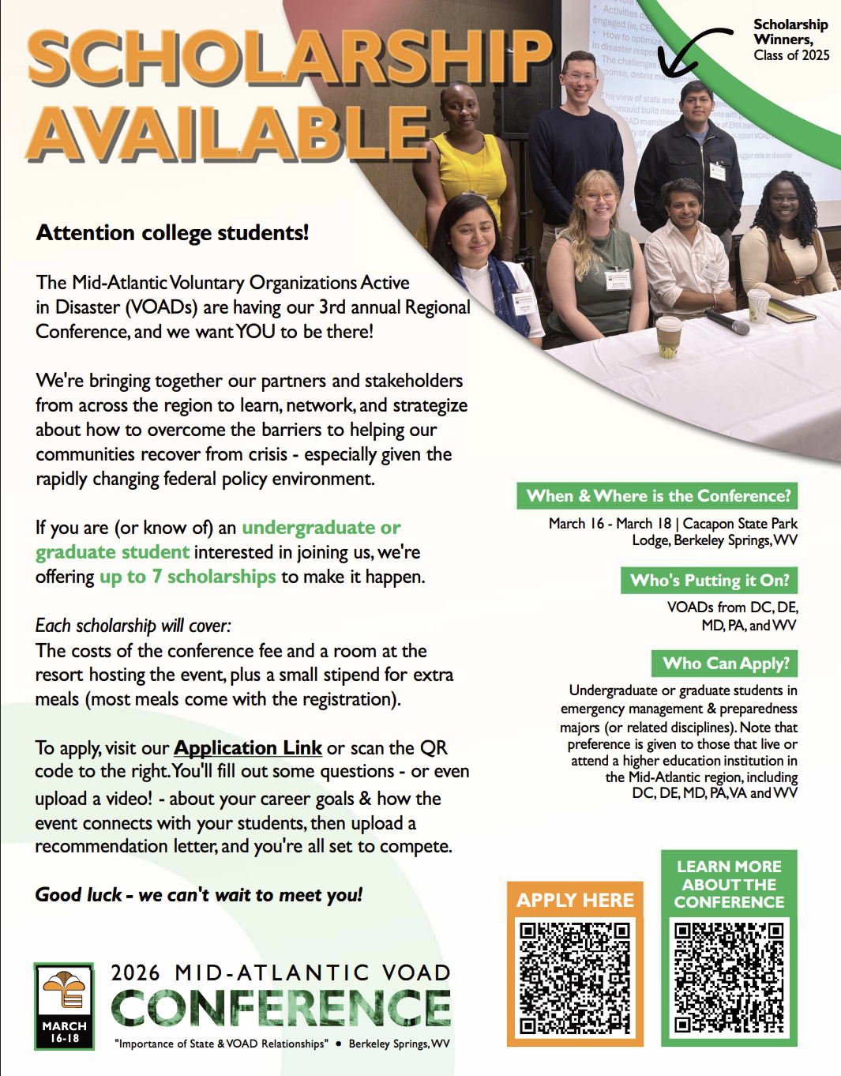

The Mid-Atlantic VOAD conference has opened the portal for scholarship applications for 2026! See the flyer for more information.

